MICHAEL T. FIFE (State Bar No. 203025)
BRADLEY J. HERREMA (State Bar No. 228976)
BROWNSTEIN HYATT FARBER SCHRECK, LLP
21 East Carrillo Street
Santa Barbara, California 93101
Telephone No: (805) 963-7000
Facsimile No: (805) 965-4333

Attorneys for: Gene T. Bahlman, William and Julie Barnes, William R. Barnes & Eldora M. Barnes Family Trust of 1989, Thomas M. Bookman, B.J. Calandri, John Calandri, John Calandri as Trustee of the John and B.J. Calandri 2001 Trust, Son Rise Farms, Calmat Land Company, Sal and Connie L. Cardile, Efren and Luz Chavez, Consolidated Rock Products, Del Sur Ranch LLC, Steven Godde as Trustee of the Forrest G. Godde Trust, Lawrence A. Godde, Lawrence A. Godde and Godde Trust, Robert and Phillip Gorrindo, Gorrindo Family Trust, Laura Griffin, Healy Farms, Healy Enterprises, Inc., Habod Javadi, Juniper Hills Water Group, Eugene V., Beverly A., & Paul S. Kindig, Paul S. & Sharon R. Kindig, Kootenai Properties, Inc., Gailen Kyle, Gailen Kyle as Trustee of the Kyle Trust, James W. Kyle, James W. Kyle as Trustee of the Kyle Family Trust, Julia Kyle, Wanda E. Kyle, Maritorena Living Trust, Jose and Marie Maritorena, Richard H. Miner, Barry S. Munz, Terry A. Munz and Kathleen M. Munz, Eugene B. Nebeker, R and M Ranch, Inc., Richard and Michael Nelson, Robert Jones, John and Adrienne Reca, Edgar C. Ritter, Paula E. Ritter, Paula E. Ritter as Trustee of the Ritter Family Trust, Sahara Nursery, Mabel Selak, Jeffrey L. & Nancee J. Siebert, Dr. Samuel Kremen, Tierra Bonita Ranch Company, Beverly Tobias, Triple M Property FKA and 3M Property Investment Co., Vulcan Materials Co. and Vulcan Lands Inc., Willow Springs Company, Donna and Nina Wilson, Ramin Zomorodi, Genz Development and Castle Ranch Estate, collectively known as the Antelope Valley Groundwater Agreement Association (“AGWA”)

Superior Court of the State of California

For the County of LOS ANGELES
ANTELOPE VALLEY  GROUNDWATER CASES  Included Actions:  Los Angeles County Waterworks District No. 40 v. Diamond Farming Co. Superior Court of California County of Los Angeles, Case No. BC 325 201 Los Angeles County Waterworks District No. 40 v. Diamond Farming Co. Superior Court of California, County of Kern, Case No. S-1500-CV-254-348 Wm. Bolthouse Farms, Inc. v. City of Lancaster Diamond Farming Co. v. City of Lancaster Diamond Farming Co. v. Palmdale Water Dist. Superior Court of California, County of Riverside, consolidated actions, Case No. RIC 353 840, RIC 344 436, RIC 344 668 | )  )  )  )  )  )  )  )  )  )  )  )  )  )  )  )  )  )  )  )  ) | Judicial Council Coordination Proceeding  No. 4408  Santa Clara Case No. 1-05-CV-049053  Assigned to The Honorable Jack Komar  AGWA RESPONSE TO PHASE IV DISCOVERY ORDER

AGWA hereby submits its responses to the Phase IV Discovery Order. This pleading contains the following attachments:
1. Exhibit A – Spreadsheet showing pumping details for each member of AGWA.
2. Exhibit B – Signed verification of spreadsheet information.
3. Links to folders containing supporting documents for spreadsheet information:
- Link to main folder containing all other folders.
- Bahlman Production folder.
- Barnes Production folder.
- Barnes folder.
- Bookman Production folder.
- Calandri Production folder.
- Cardile Production folder.
- Castle Ranch-Zomorodi Production folder.
- Chavez Production folder.
- Del Sur Ranch Production folder.
- Godde Production folder.
- Gorrindo Production folder.
- Griffin Production folder.
- Healy Farms Production folder.
- Javadi-Sahara Nursery Production folder.
- Kindig Production folder.
- Kremen-Tierra Bonita Production folder.
- Kyle Production folder.
- Maritorena Production folder.
- Miner Production folder.
- Munz Production folder.
- Nebeker Production folder.
- Reca Production folder.
- R&M Production folder.
- Selak Production folder.
- Siebert Production folder.
- Vulcan-Calmat Production folder.
- Willow Spring Production folder.
- Wilson Production folder.

Dated: December 21, 2012 | Brownstein Hyatt Farber Schreck, LLP  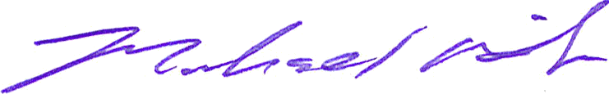  By:  Michael T. Fife  Attorneys for Defendant

PROOF OF SERVICE

STATE OF CALIFORNIA,
COUNTY OF SANTA BARBARA

I am employed in the County of Santa Barbara, State of California. I am over the age of 18 and not a party to the within action; my business address is: 21 E. Carrillo Street, Santa Barbara, California 93101.

On December 21, 2012, I served the foregoing document described as:

AGWA RESPONSE TO PHASE IV DISCOVERY ORDER

on the interested parties in this action.

By posting it on the website by 5:00 p.m. on December 21, 2012.

This posting was reported as complete and without error.

(STATE) I declare under penalty of perjury under the laws of the State of California that the above is true and correct.

Executed in Santa Barbara, California, on December 21, 2012.

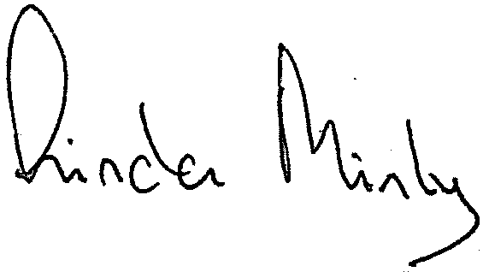
LINDA MINKY | ___________________________________
TYPE OR PRINT NAME | SIGNATURE

